* Purpose : Classwork.
* Date : 26/12/2025
* Author : Vikas Srivastava
* ID : 55984
* Batch ID : 25SUB4505

- Code : Write a program to implement a BankAccount class using object-oriented programming concepts in C++, where data members store account details and member functions perform operations such as deposit, withdrawal, and balance display.
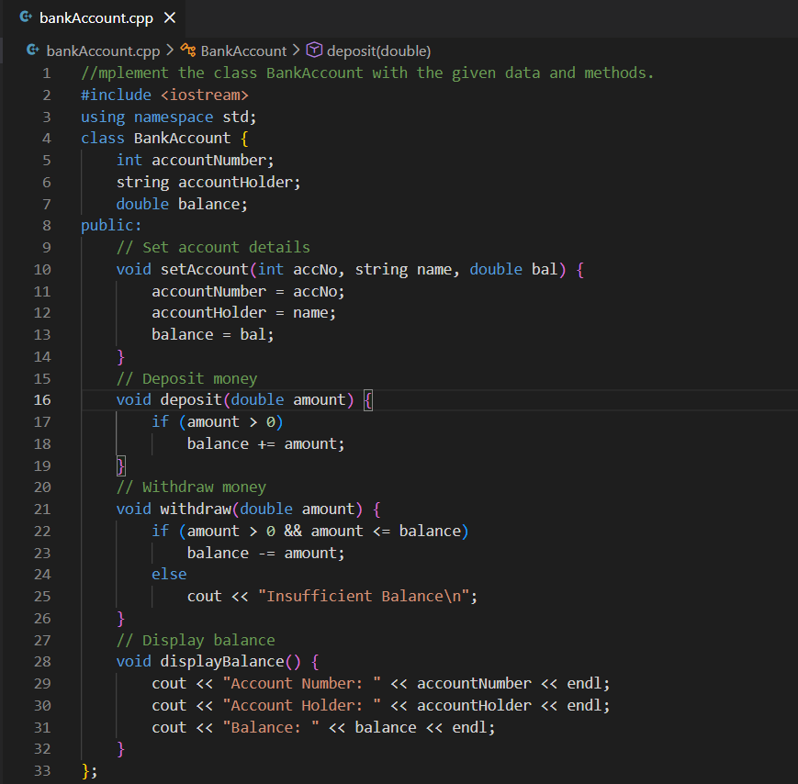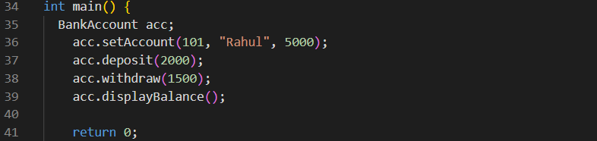
Output :
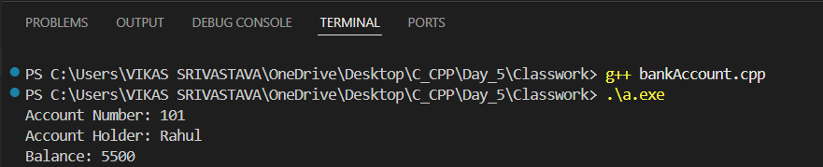

- Code : Write a program to implement a Calendar class in C++ that stores date information and provides member functions to set the date (with default values), validate the date, check for leap year, determine the maximum days in a month, and display calendar-related details using object-oriented principles.
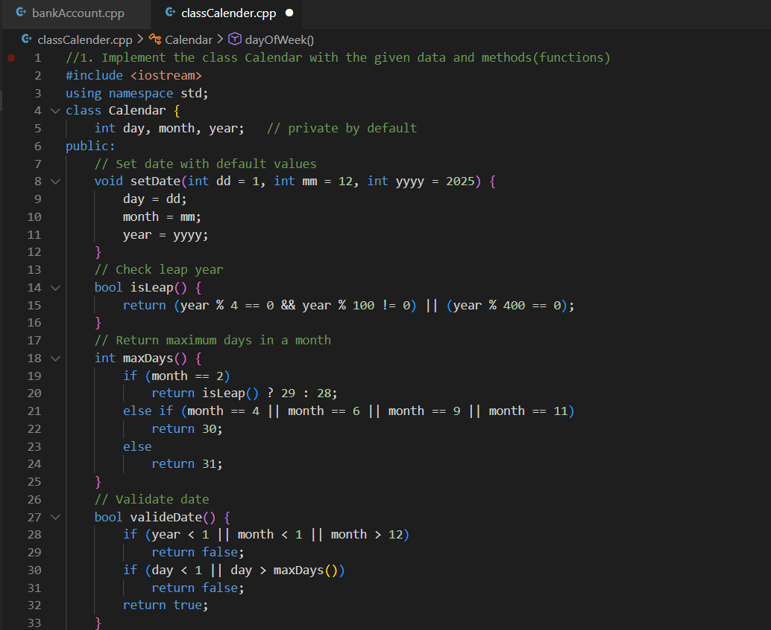
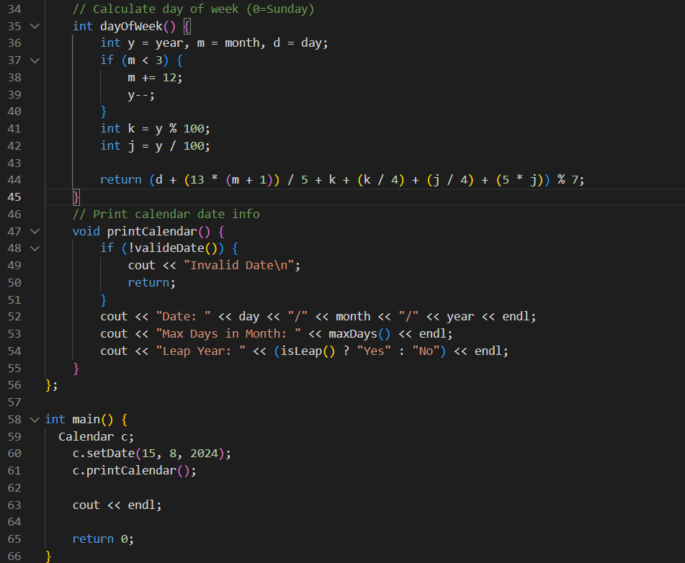
Output :
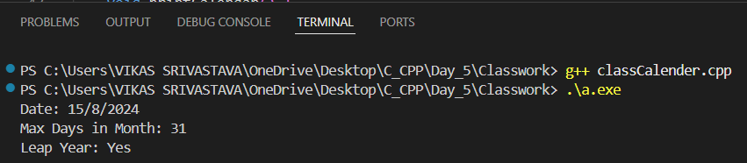

- Code : Write a program to implement a Num class in C++ that stores a number and provides member functions to set and display the number, check whether it is even, and check whether it is a prime number, demonstrating basic object-oriented programming concepts.
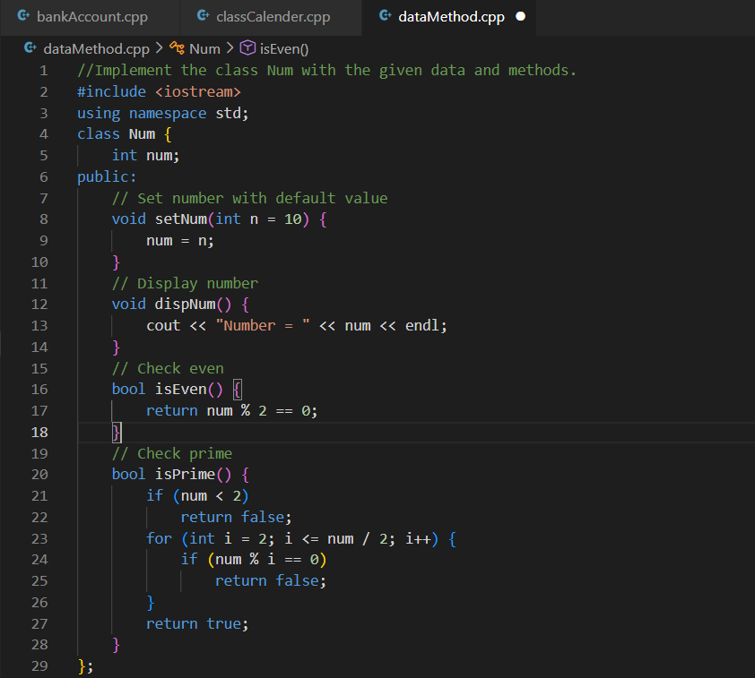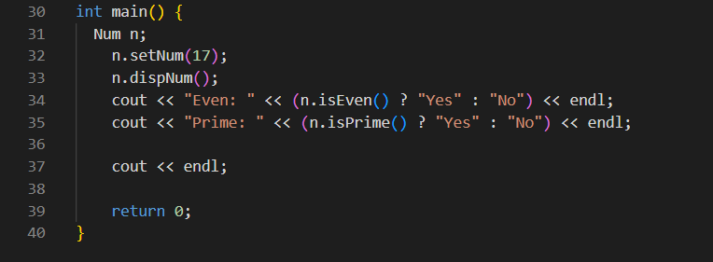
Output :
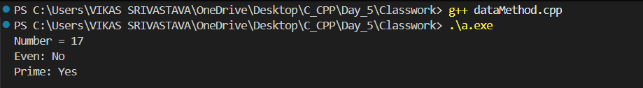
- Code : Write a program to demonstrate how a C-style string can be stored inside a class using a character array, initialized through a constructor, and processed using standard string functions like strcpy() and strlen() to display the string and its length.
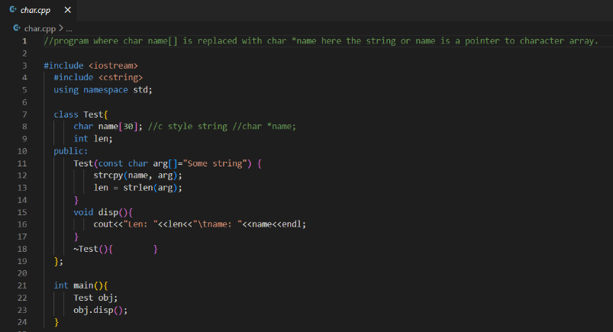
Output :
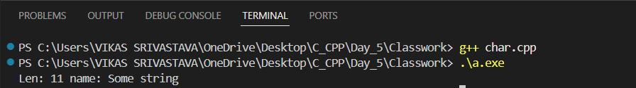
- Code : Write a program to define an Employee class in C++ with private data members and public member functions to accept employee details (ID, name, salary) and display them, demonstrating encapsulation and basic object-oriented programming concepts.
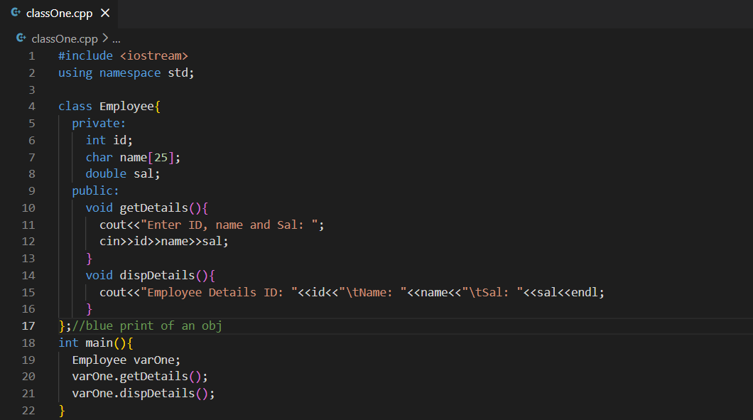
Output :
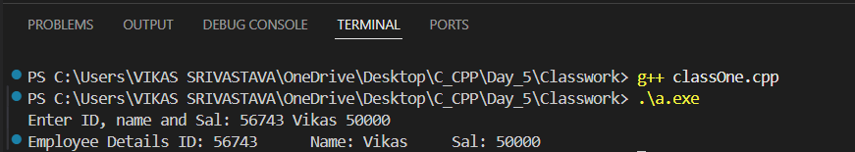
- Code : Write a program to demonstrate different types of constructors in C++, including the default constructor, single-parameterized constructor, and copy constructor, showing how objects are created and initialized in different ways.
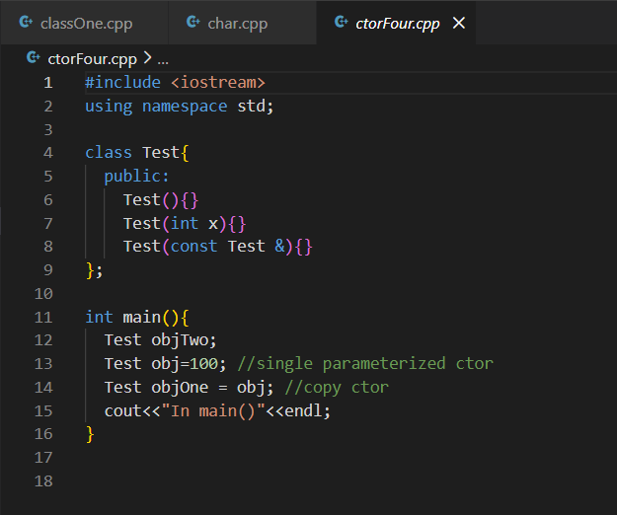
Output :
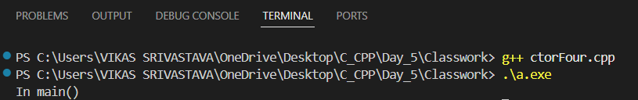

- Code : Write a program to demonstrate the automatic invocation of a constructor and destructor in C++, where the constructor is called when an object is created and the destructor is called when the object goes out of scope at the end of the program.
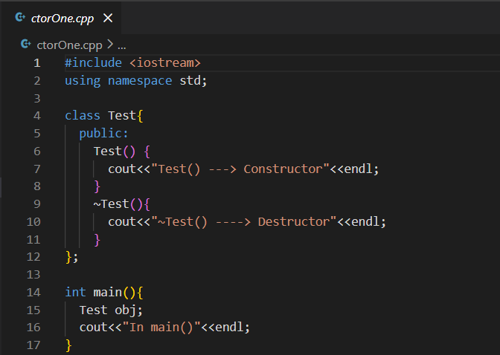
Output :
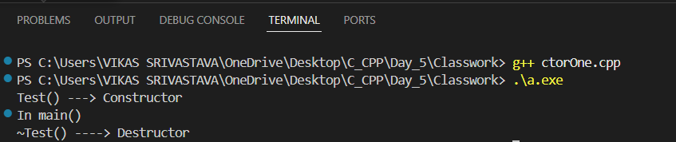
- Code : Write a program to demonstrate the use of default and parameterized constructors in an Employee class to initialize employee details and display them, highlighting constructor overloading and object initialization in C++.
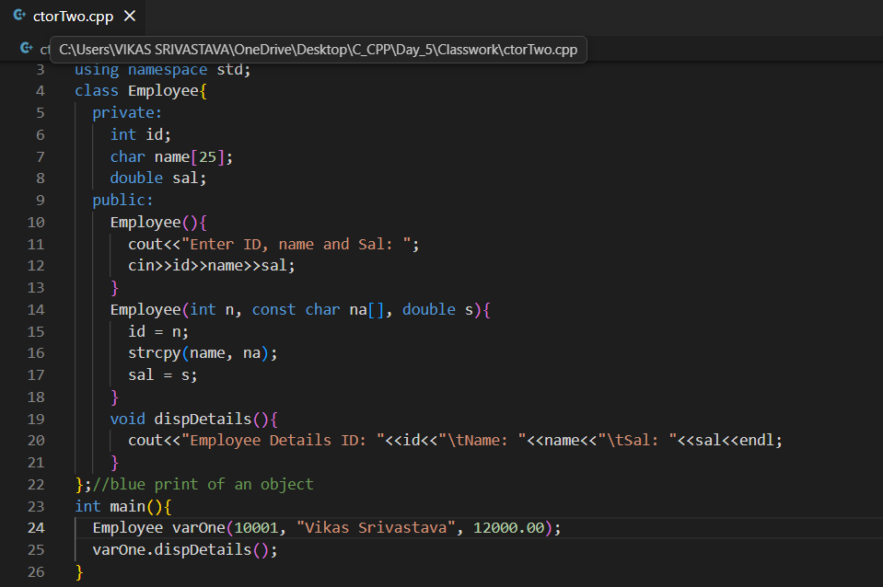
Output :
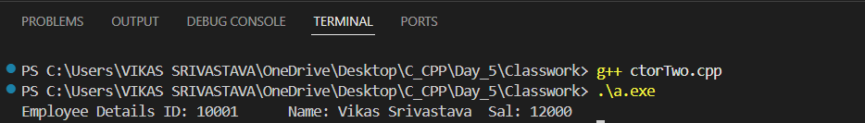

- Code : Write a program to demonstrate call by reference in C++ using pointers, where a function modifies the value of a variable defined in the calling function by accessing its memory address.
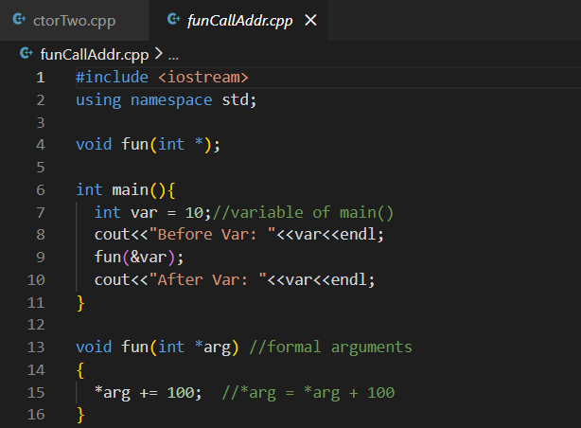
Output :
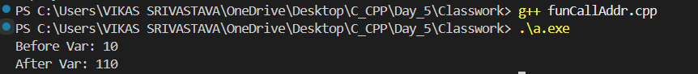
- Code : Write a program to demonstrate call by reference in C++ using reference variables, where a function directly modifies the original variable without using pointers.
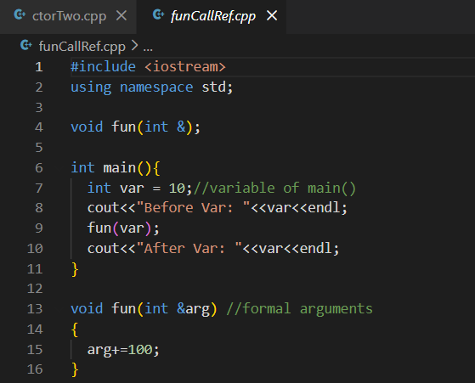
Output :
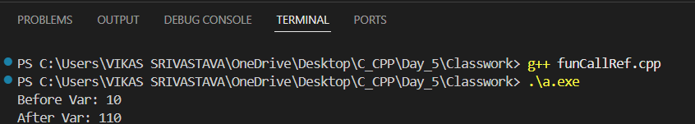

- Code : Write a program to demonstrate function overloading in C++, where multiple functions with the same name but different parameter lists are defined and the appropriate function is selected at compile time based on the arguments passed.
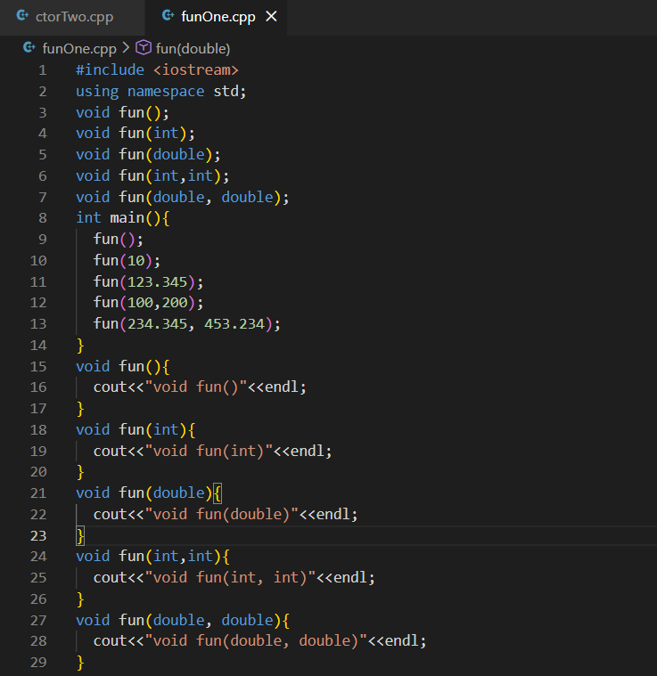
Output :
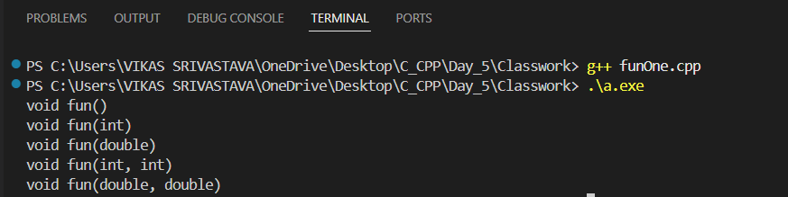
- Code : Write a program to demonstrate function overloading in C++ and show how explicit type casting affects function selection, where casting a floating-point value to int forces the compiler to call the integer version of the overloaded function.
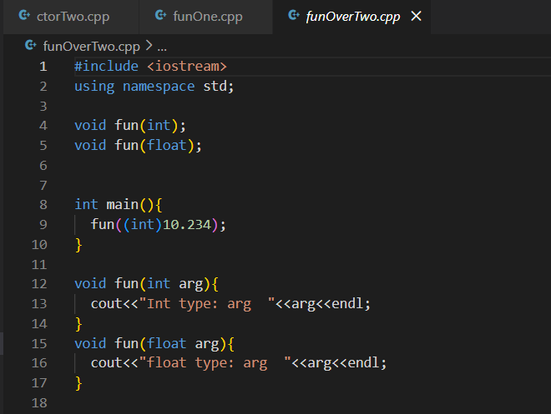
Output :

